**Name: Alves Renato Sennellius**

**SID: 2602130666**

Figma Link: <https://www.figma.com/file/Jo14oH8ADrd4KTXPE5BEsd/HI-Toys?type=design&node-id=0%3A1&t=ydYFtgZpw9Y9Kp24-1>

This website has 5 main pages:

1. **Home Page**

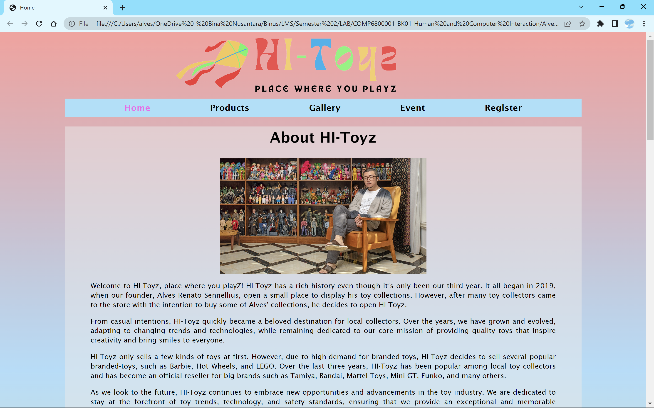

This page contains a background story on how HI-Toyz was apparently founded by "Alves Renato Sennellius" with a photo of the founder.

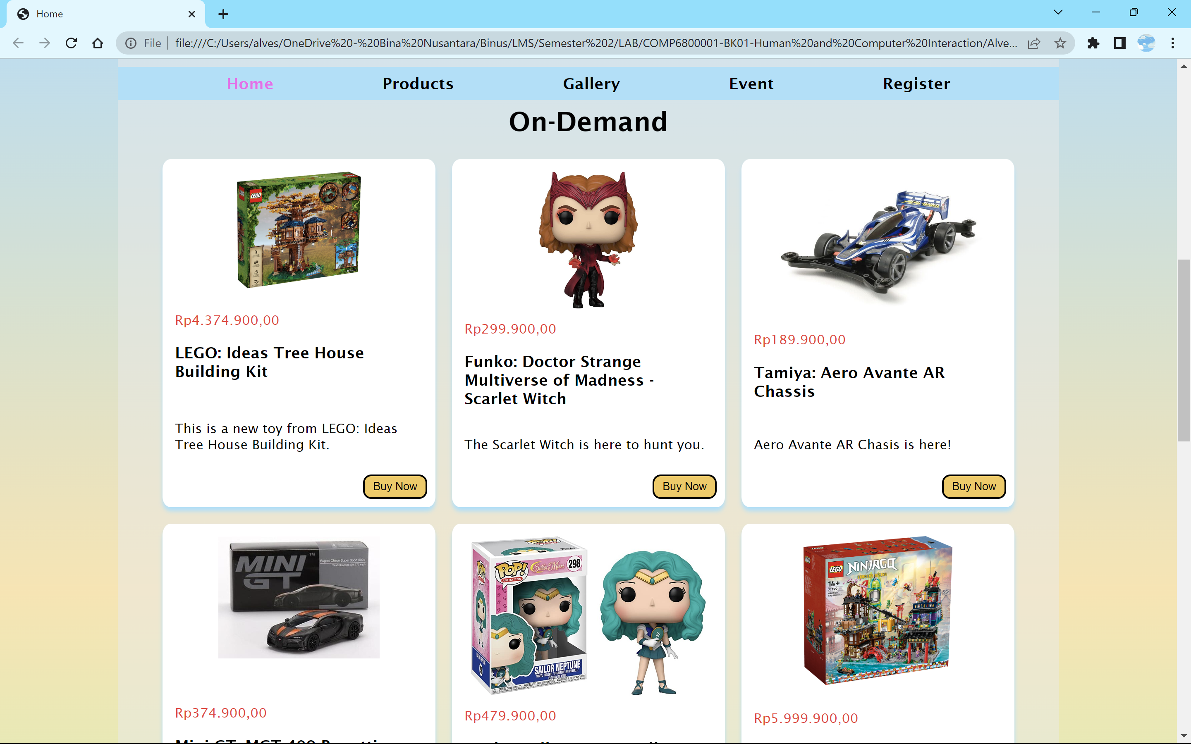

This page also shows 10 popular products from the store in the form of a grid gallery. Each box contains information such as price, name, description, and image of the product. There's a buy button for each product but is linking nowhere.

1. **Product Page**

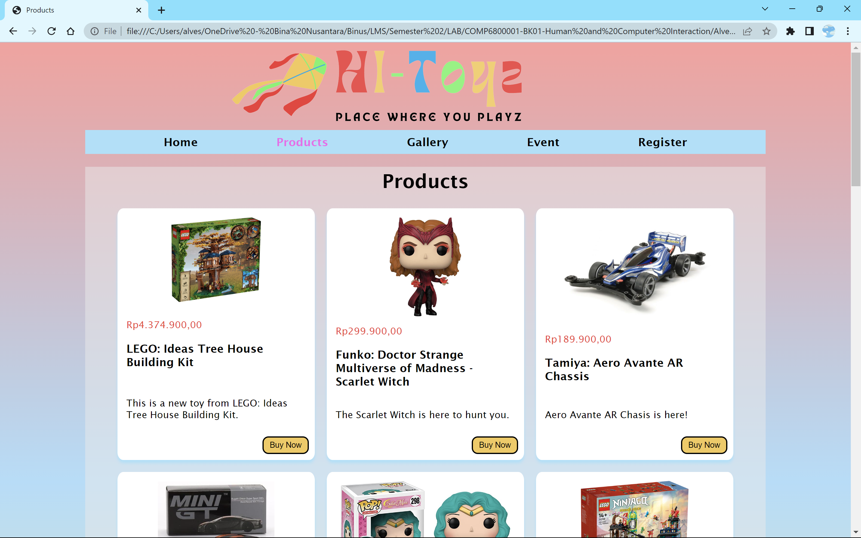

This page shows customers the products that we sell. There are at least 15 products shown to customers in the form of a grid gallery. Each box shows information such as the product's name, price, description, and image. There's a buy button for each product but linking nowhere.

1. **Gallery Page**

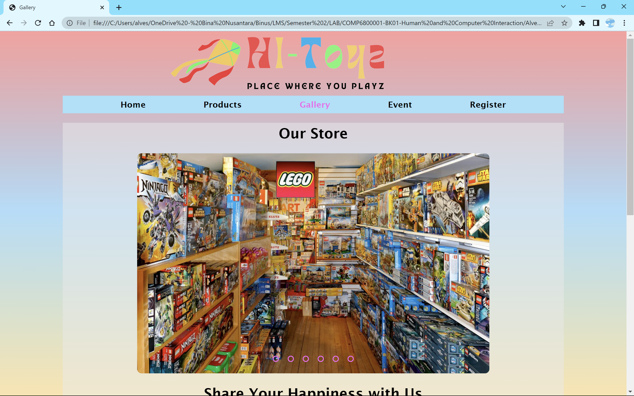

This page shows customers the pictures of the store and customers of HI-Toyz shown in the form of a slider. There are 6 pictures for the “Our Store” gallery and 7 pictures for the “Share Your Happiness with Us" gallery.

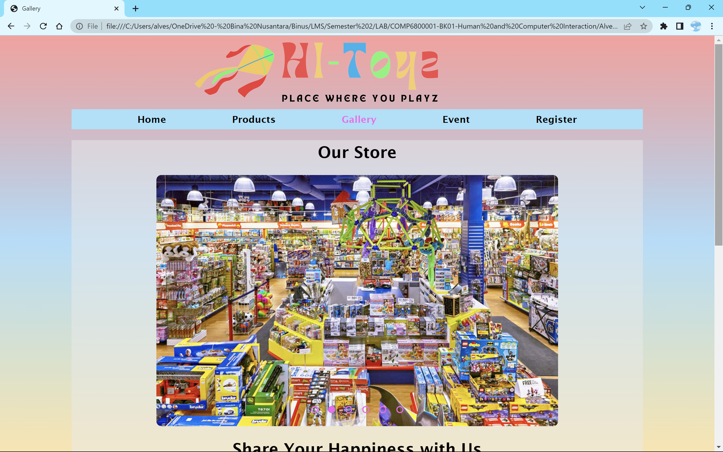

Customers can click on the radio button to change the image they want to see. Each radio button is connected to the image orderly. Once the button is clicked, the slider will slide the tergeted image. “Our Store” gallery displays the look of our store and the sections inside.

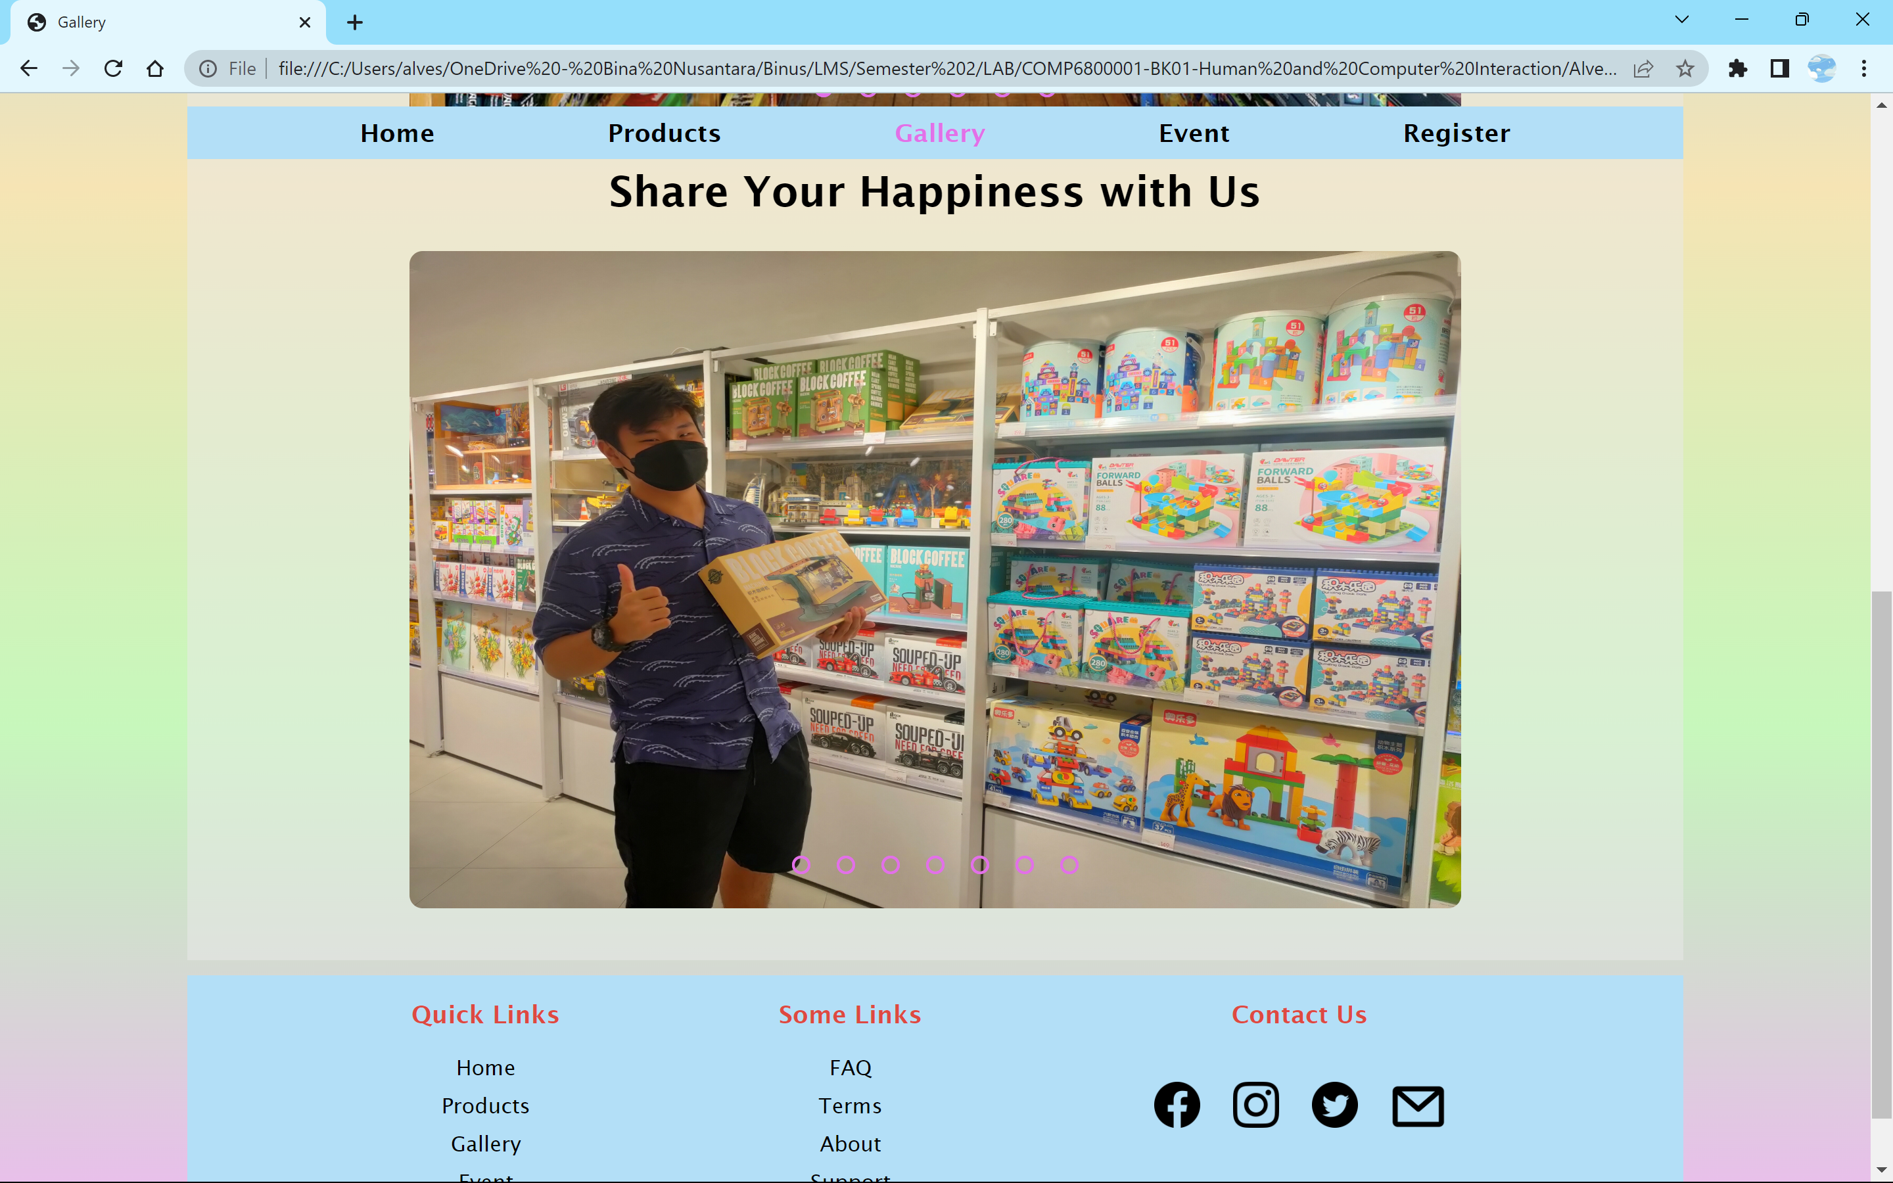

“Share Your Happiness with Us” gallery is a section that displays our customers when they visit our store. The displyed images are taken and posted with their permission. This section shows how many customers are very happy when they visit our store and hopefully will attract new customers.

1. **Event Page**

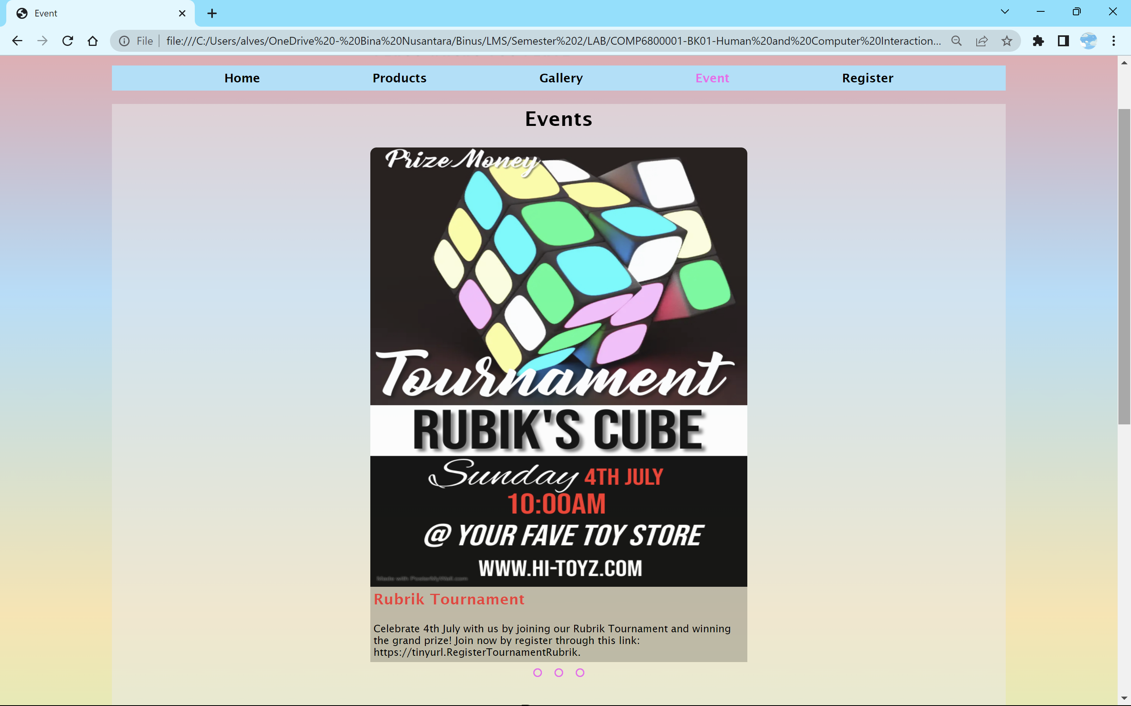

This page contains information for events and promos held by HI-Toyz. We displayed all the flyers and banners in the form of a grid gallery. There are two galleries, the first one is “Events” gallery and the second one is "Promos” gallery. Both contain information such as image, name of the event or promo, and the description.

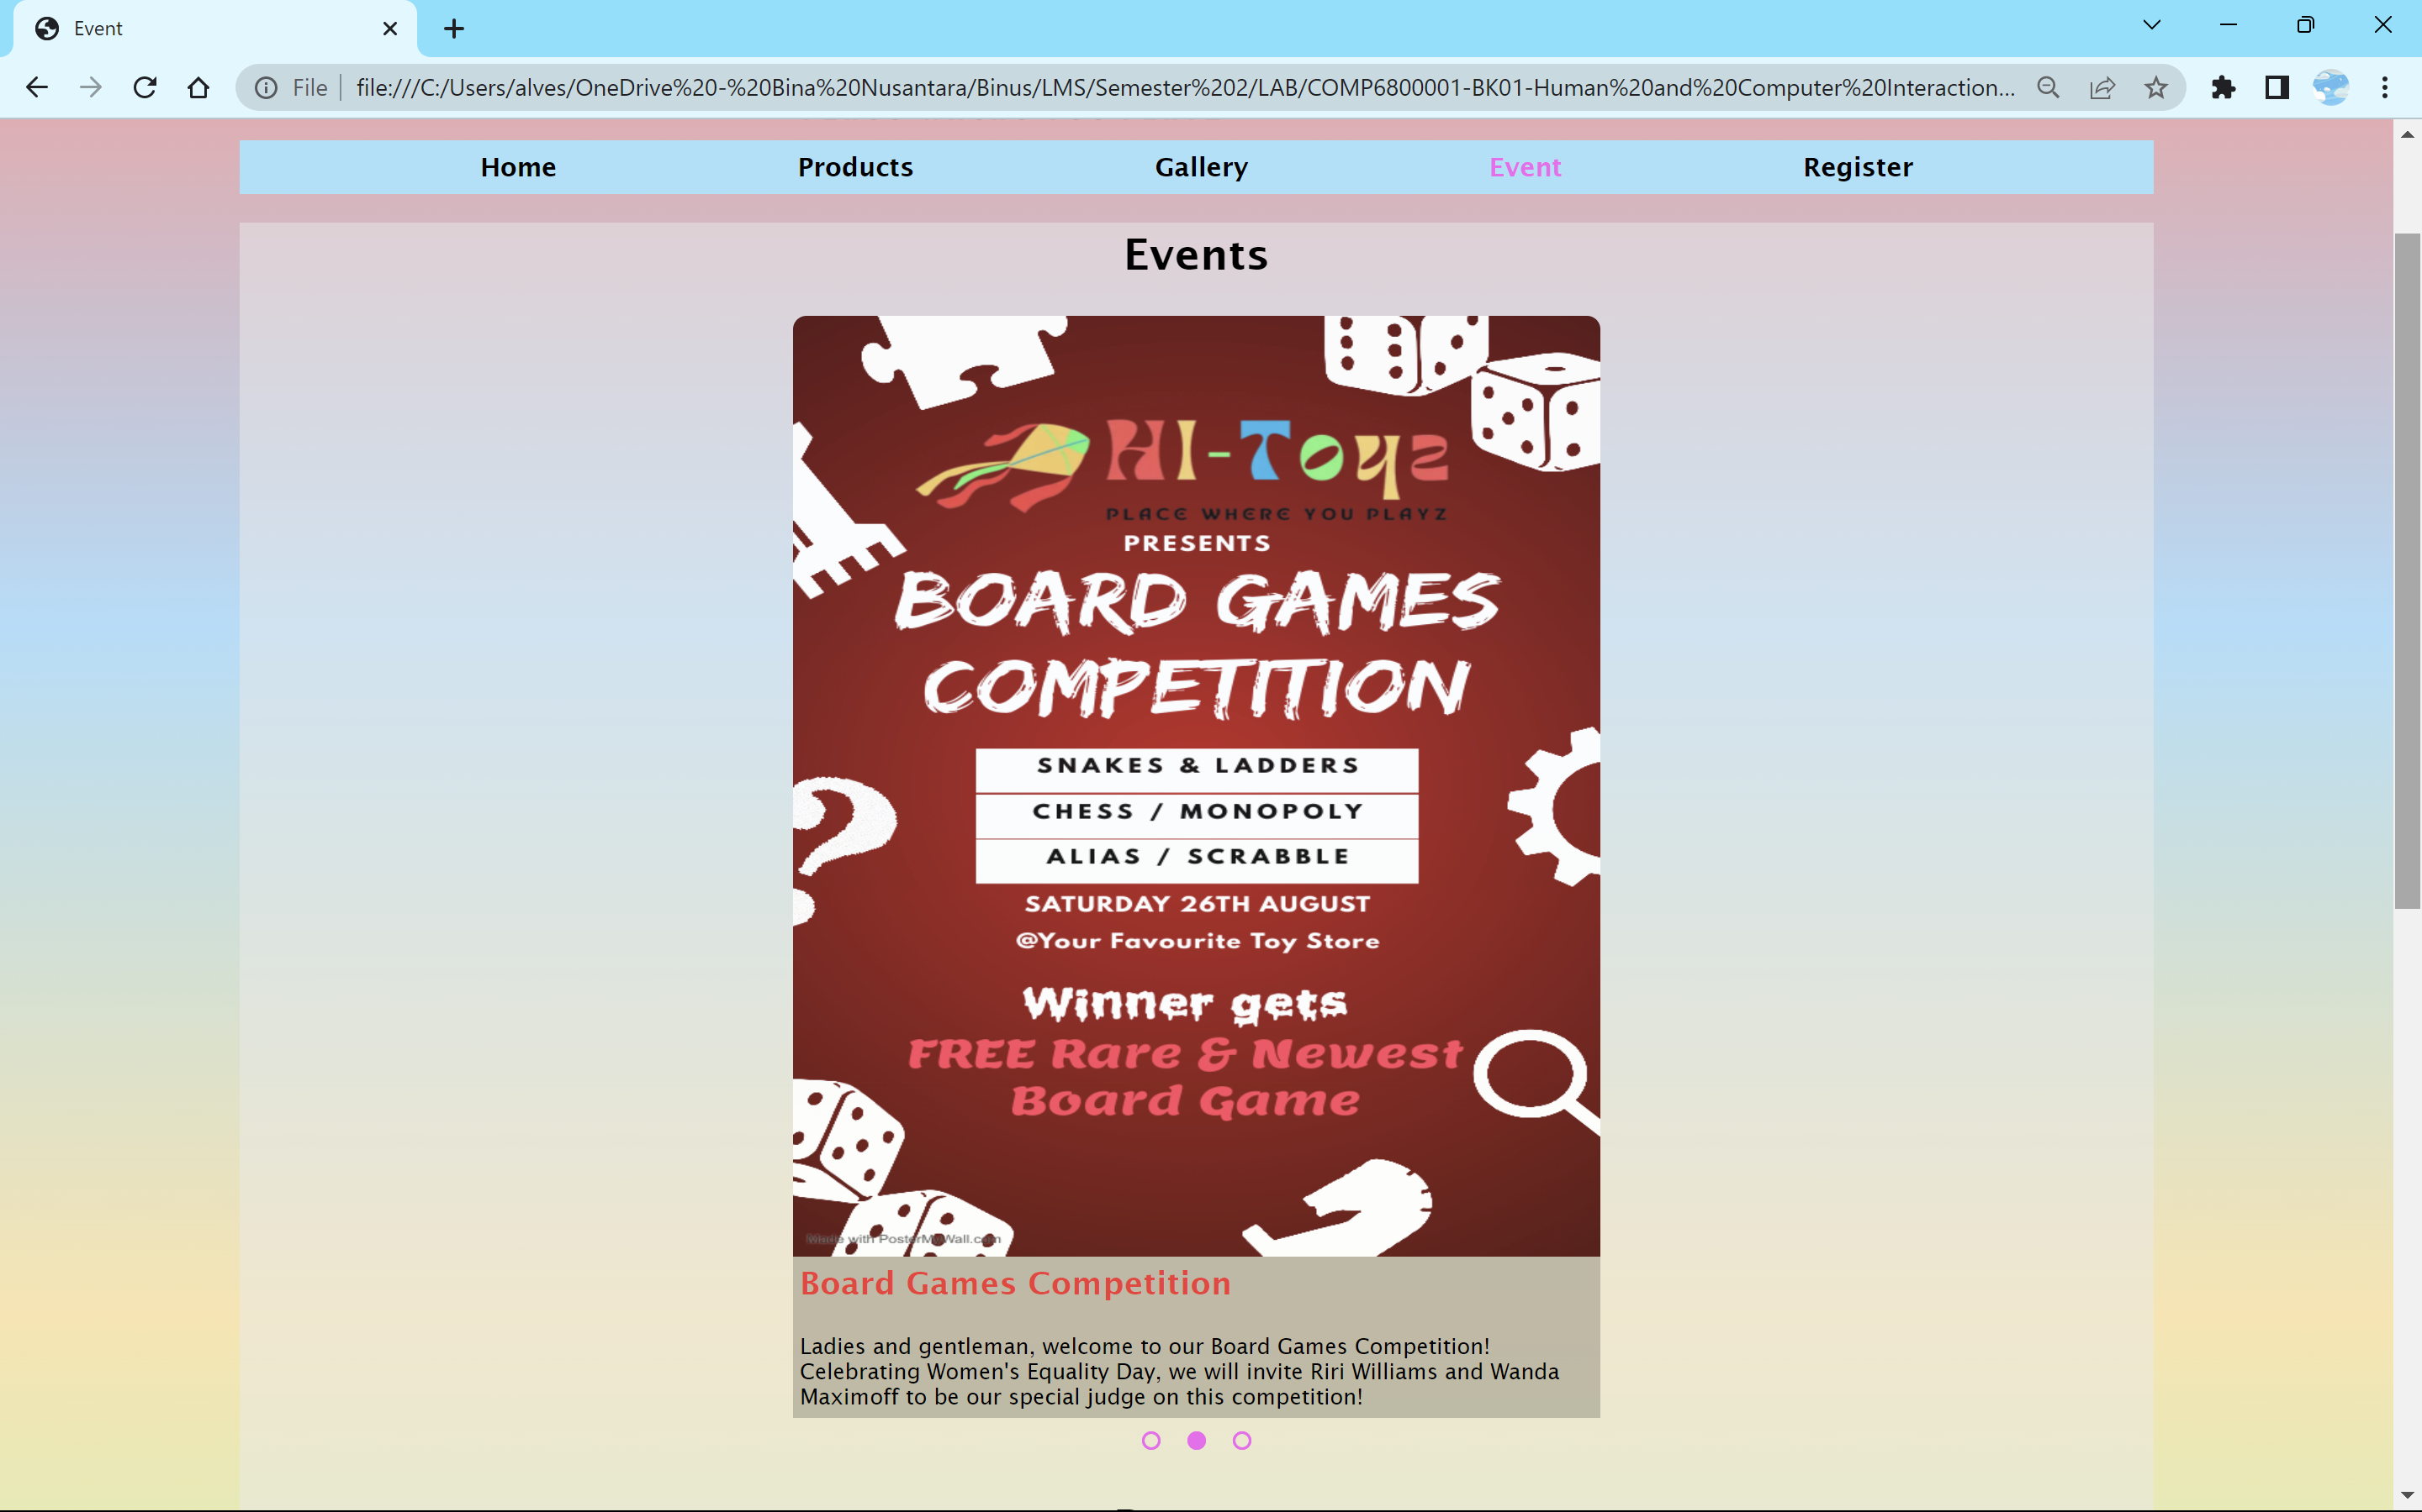

The gallery works the same as the one from “Gallery Page”. Customers can click on the radio button to change the image they want to see. Each radio button is connected to the image orderly. Once the button is clicked, the slider will slide the tergeted image. “Events” gallery displays the flyers for events, such as competitions or parties, held by us.

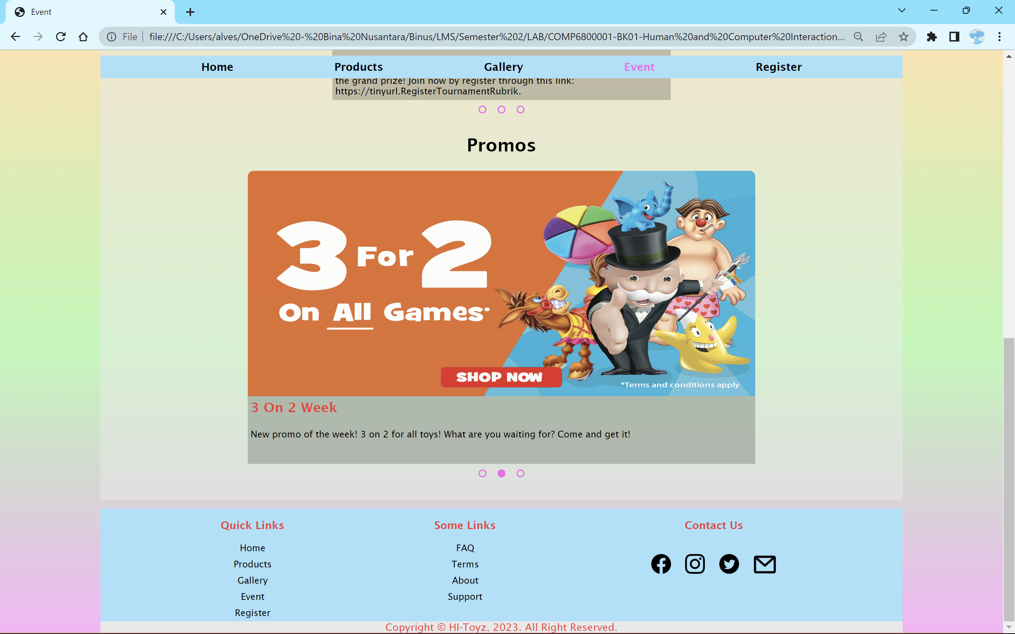

“Promos” gallery displays banners for any kind of promo we do. It could be a discount promo for kids or a certain event such as Christmas discount, or even “3 for 2” promo like the image above. With those promos, hopefully, customers will be attracted to buy toys at our store.

1. **Register Page**

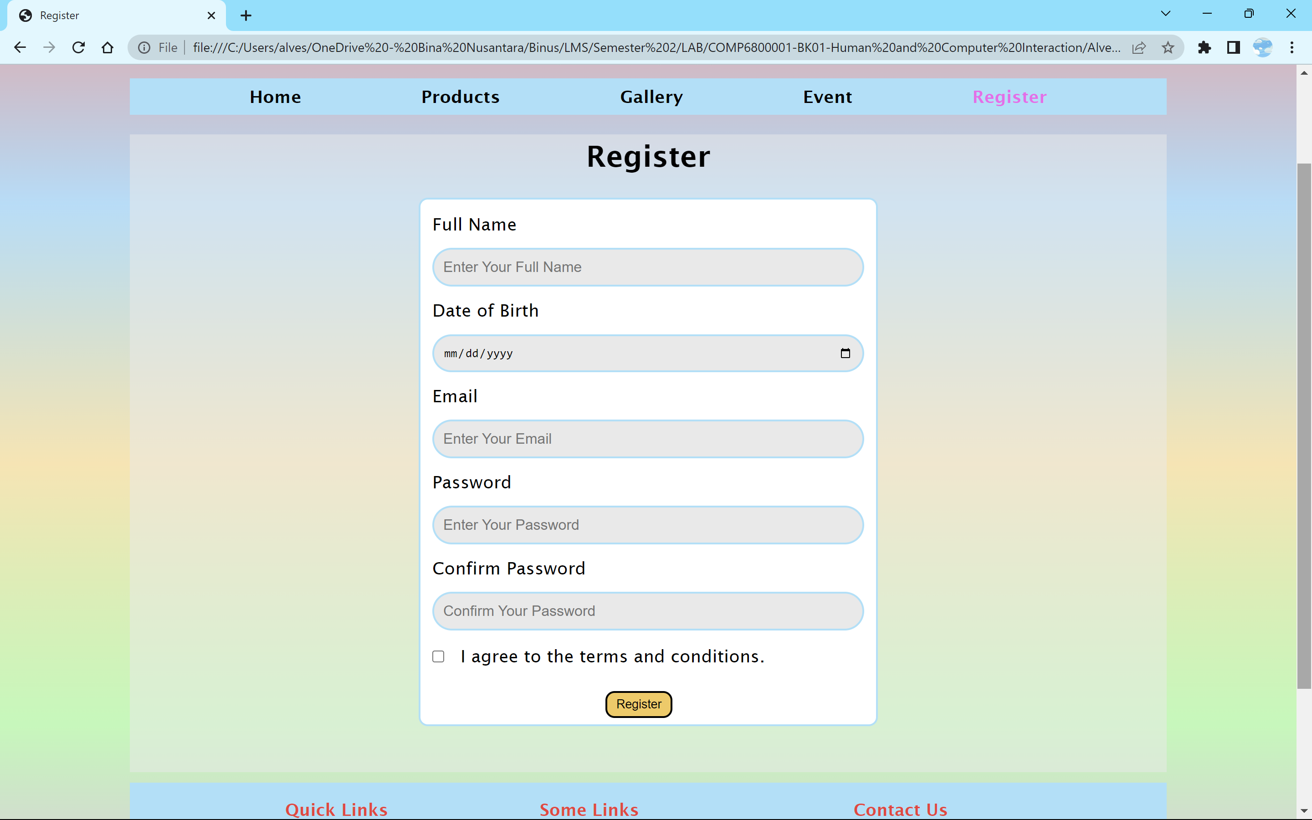

This is a page for the user to make an account to continue exploring the website. The user will have to fill in their full name, date of birth, and email, make a password and confirm the password, agree to terms and conditions, and, last but not least, submit their registration form.

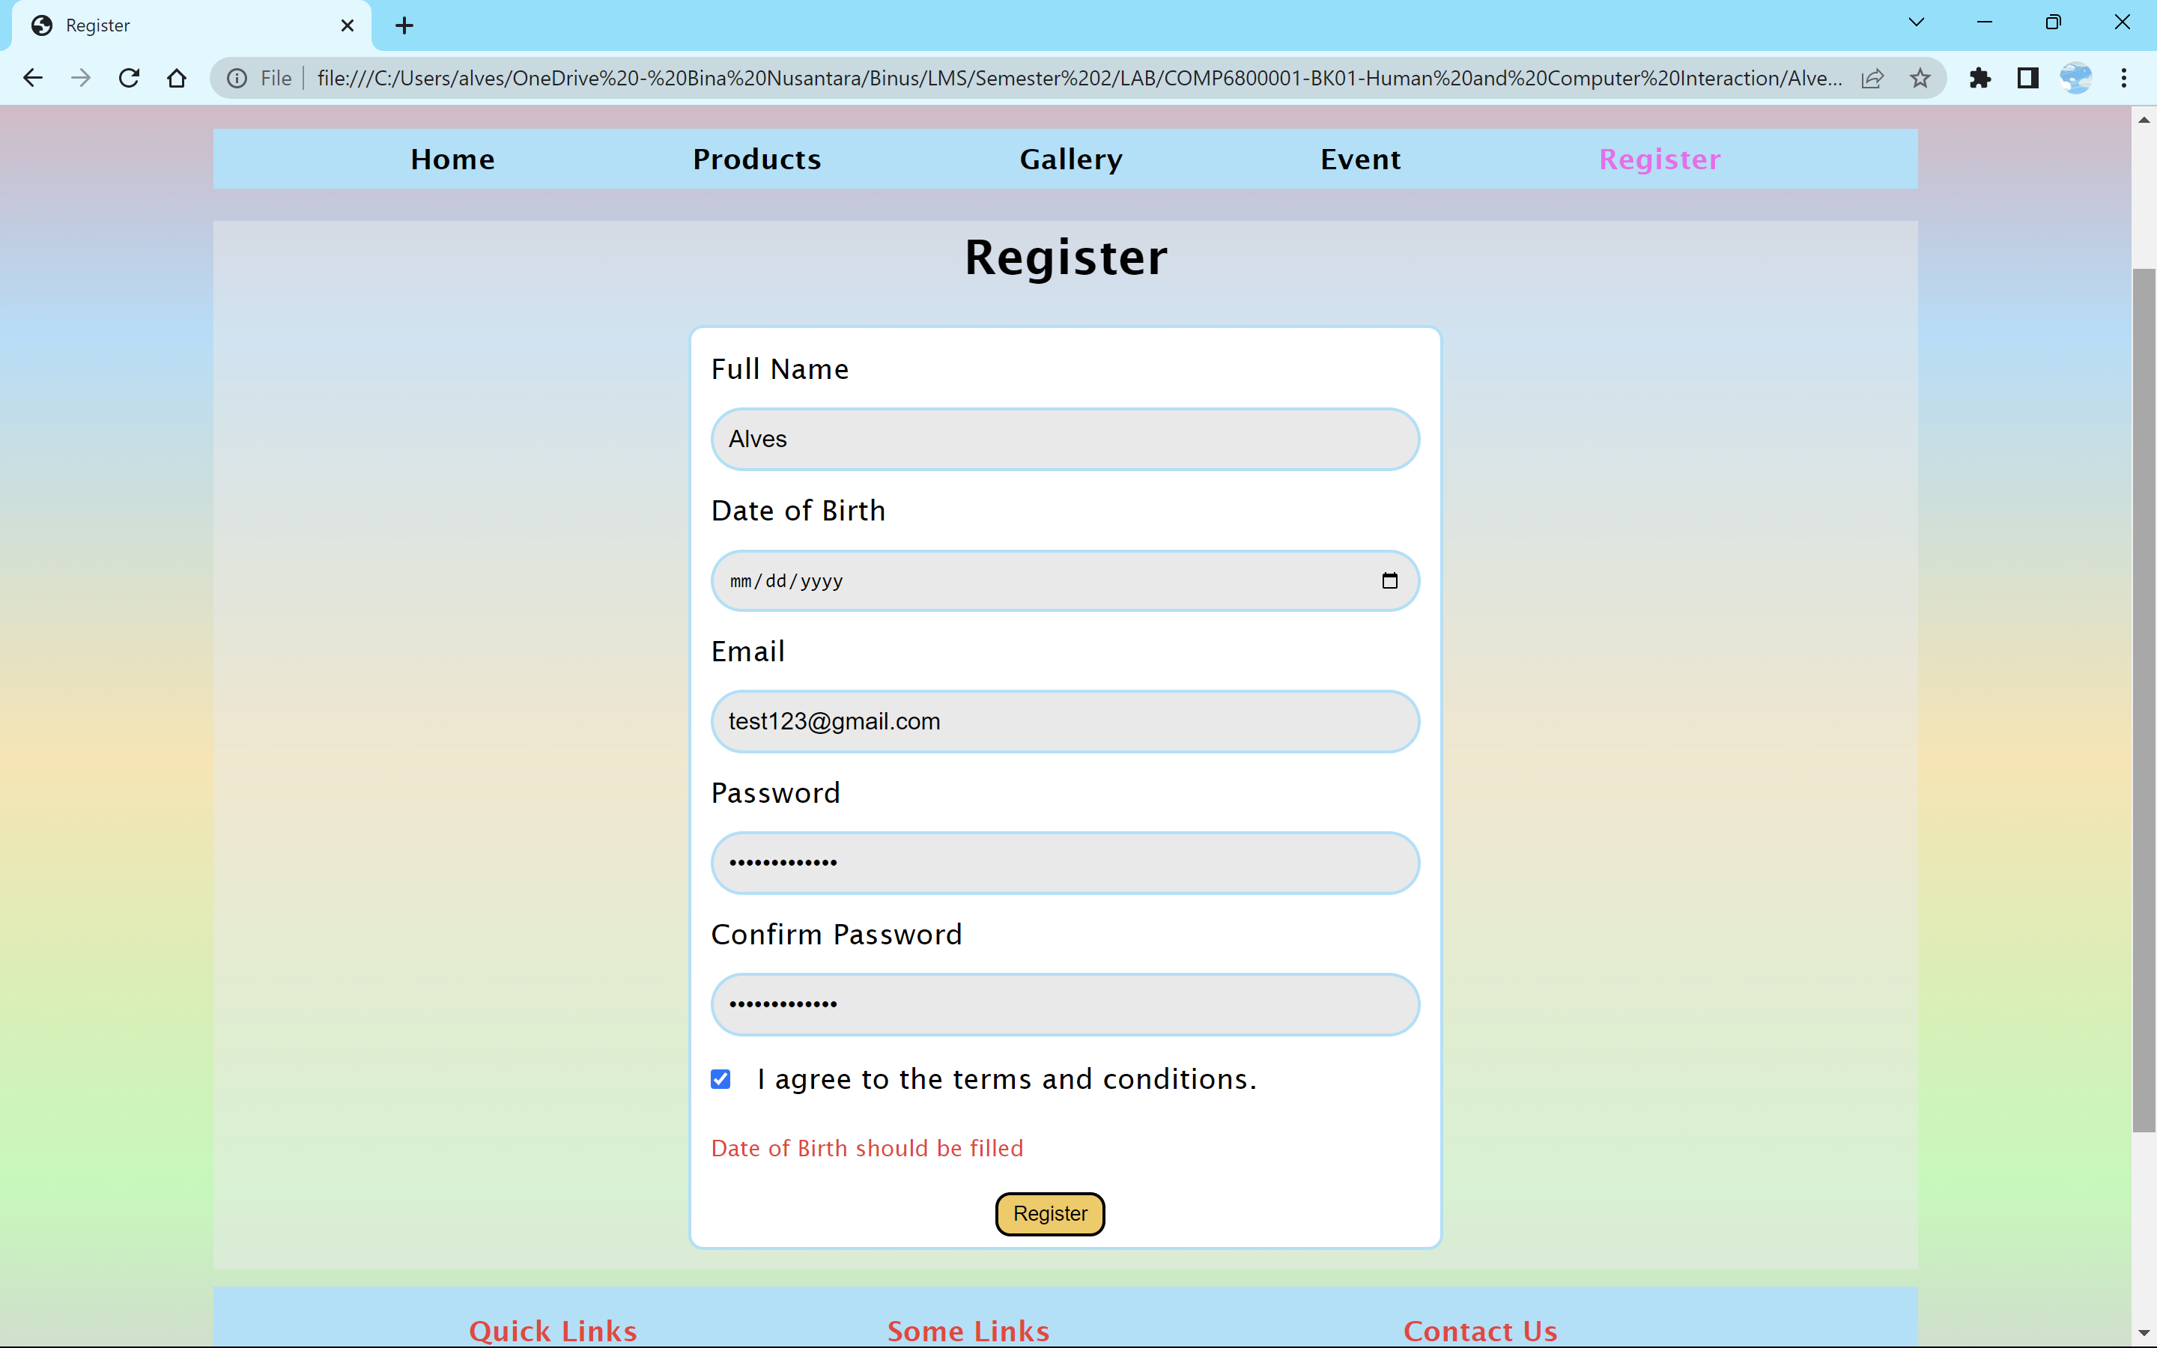

When filling in the form, the user needs to pay attention to the validation of each field. If not, then certain validation sentence will appear below the check box.

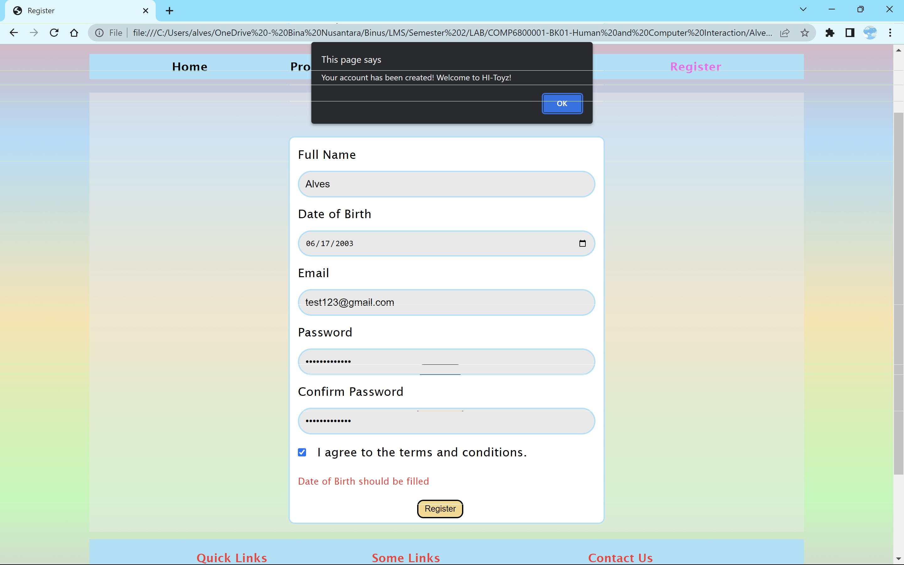

Once the user has submitted their registration form, the website will alert the user about their successful account-making. After the user has clicked the “OK” button, the data inserted will disappear as if they are all sent to the database.